Appendix B: Emotion Regulation task

A demonstration of the emotion regulation task is available at http://cogflex.com.au/users/kit/ERT-demo/ERT.html

Premise

The emotion regulation task involves selecting from emotion regulation strategies to help another participant manage their emotions. The cover story suggests that another participant to whom you’ve been randomly “matched” is viewing negative stimuli and you are to help them manage their emotions. Unbeknownst to the participant the other person does not exist. On each trial they select a emotion regulation strategy (either determined by the experimenter or in a free response fashion)

Structure

Each trial consists of a decision about what “advice” to provide your partner. Options include various emotion regulation strategies (in a multiple-choice fashion) or free response (i.e. the participant can provide any advice they want). They are then falsely told to wait a few seconds while their partner views the negative image, and then they are provided feedback. The feedback will take various forms in different studies (numerical feedback, emojis, human faces, binary feedback (e.g. thumbs up/down)

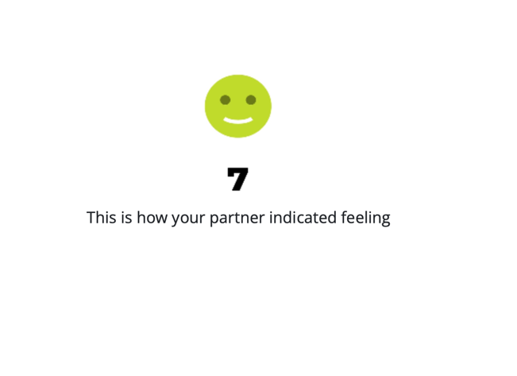

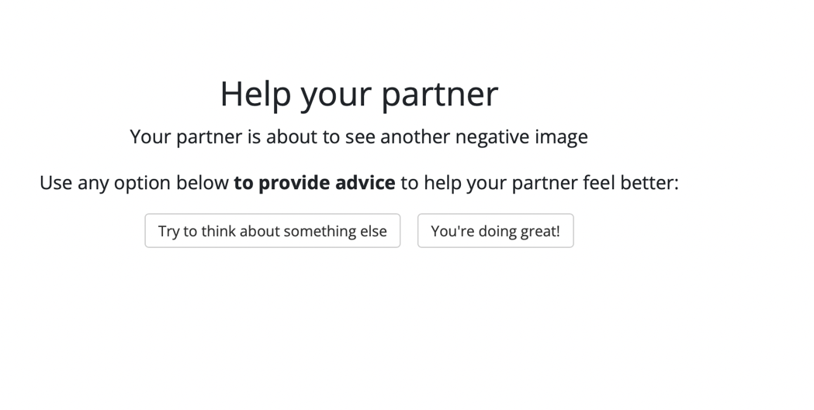
At the end of the experiment participants make effectiveness ratings, such as how effective they think each strategy was, how helpful they think they were at helping their partner, and whether they would use a strategy in the real world.

